**Cyber Escape Room**

A Technical Report submitted to the

Department of Informatics and Networked Systems

at the School of Computing and Information

University of Pittsburgh

Pittsburgh, Pennsylvania

Insert Author Name

Spring 2024.

Project Team Members

Colby Geary

Noah Howells

Matt Madl

Samuel Scott

Caroline Spitz

Signature __________________________________________ Date __________

Student Name ←←←← Change this into your name and SIGN above the line

Advisor: Dr. Ahmed Ibrahim, Department of Informatics and Networked Systems

**Table of Content**

**Abstract 2**

**List of Figures 3**

**1. Introduction 3**

1.1 Problem Statement 4

1.2 Contributions 5

**2. Related Work 5**

**3. System Design 5**

3.1 System Requirements 6

3.2 Wireframes 7

3.3 Sample Code 8

3.4 Sample Tests 9

3.5 Code Coverage 10

3.6 Installation Instructions 10

**4. Results 11**

**5. Conclusions 12**

**6. Future Work 13**

**7. References 13**

### **Abstract**

A good abstract explains in one line why the paper is important. It then goes on to give a summary of your major results, preferably couched in numbers with error limits. The final sentences explain the major implications of your work. A good abstract is concise, readable, and quantitative.

Length should be ~ 1-2 paragraphs, approx. 400 words.

Abstracts generally do not have citations.

Information in the title should not be repeated.

Be explicit.

Use numbers where appropriate.

Answers to these questions should be found in the abstract:

What did you do?

Why did you do it? What question were you trying to answer?

How did you do it? State methods.

What did you learn? State major results.

Why does it matter? Point out at least one significant implication.

### **List of Figures**

Figure 1. Desktop Wireframe……….………………………………………………. Page Number

Figure 2. Password Entry Wireframe……….………………………………………. Page Number

Figure 3. Security Image……………………………………………..………………Page Number

Figure 4. Playtesting……………………..…………………………………………. Page Number

### 

### 

### **1. Introduction**

This part should be 2-3 simple, easy to read paragraphs. Be sure to include a hook at the beginning of the introduction. This is a statement of something sufficiently interesting to motivate your reader to read the rest of the thesis, it is an important/interesting scientific problem that your thesis either solves or addresses. You should draw the reader in and make them want to read the rest of the thesis. Think about what made you choose this project to work on!

#### 1.1 Problem Statement

As a professor at the University of Pittsburgh, the client, Professor Ahmed Ibrahim, worked in

Start with a description of what the organization/client you are working offers.

- What work do they do?

- What problem(s) they faced?

- How do they currently solve that problem as of the beginning of this academic year, before you work on your solution?

- How long does it take?

- What problems does the current way of solving it cause?

Then, include a paragraph or two on how and why your system will be beneficial.

#### 1.2 Contributions

What did you accomplish to contribute to the solution of the problem statement? Which parts were you able to solve or make better. In the subsection, you can mention things like: “we were able to create a web based application which allows the organization’s management team view how many clients used their product”. The rest of this thesis is organized in four sections. In Section 2, related work is presented. Section 3 shows our approach to address the aforementioned problem stated, our web-based application, as well as the system design. The results of our work are discussed in Section IV. Finally, Section VI concludes this thesis.

### **2. Related Work**

The goal in this section is to give a context of what else is out there.

* What other systems exist that do similar things?

* Are they custom written, or generic?

* Why don't they fit the bill?

- Show where your system fits into everything.

<https://www.thalesgroup.com/en/cyber-escape-room>

* Not too portable

<https://www.youtube.com/watch?v=ICAFqq4BMS4&ab_channel=SANSInstitute>

* Too technical

### **3. System Design**

First, start by describing the high level goals of your system. A few sentences which quickly describe what each type of users should be able to do. Also, mention what language/framework will you use to develop the system. Why did you choose such language/framework? What license is your code under?

#### 3.1 System Requirements

Using your own words, state the importance of gathering system requirements. Then, include a list of your “minimum requirements”, “desired requirements”, and “optional requirements”. You can state the due date for each type of requirements to be completed/developed.

#### 3.2 Wireframes

In the first sprint, we developed early wireframes for the digital parts of the escape room. As the narrative was solidified, we discussed the need for a password entry prompt for the players. In addition, we constructed an HTML file to mirror the structure of a computer desktop. Using this desktop, the player would be able to search through the attacker’s files for clues. We also constructed a wireframe to refine our goals for the security footage puzzle.

Desktop Wireframe: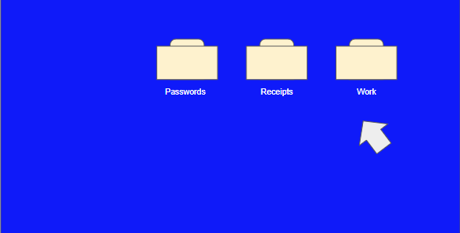

Password Entry Wireframe: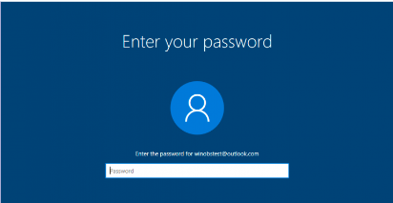

Security Wireframe:

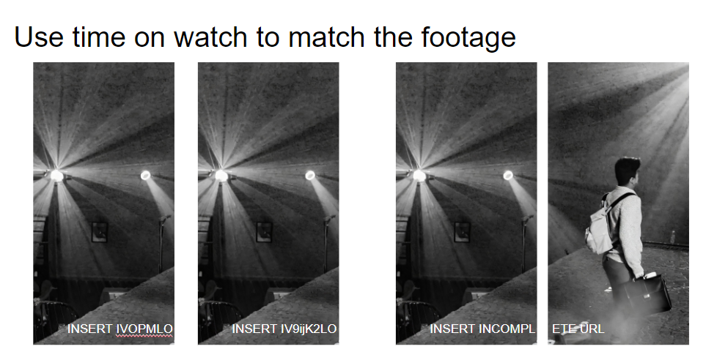

#### 3.3 Sample Code

The following code snippet is from the first part of the desktop.html file. This file simulates a laptop desktop. The players can navigate through the attacker’s files by clicking on the folders. 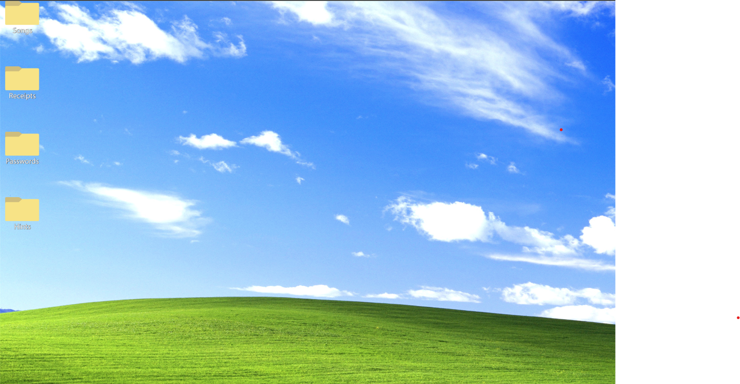

Final Product:

Code:

<style>

body {

background-color: #003cff;

background-image: url('windows.jpg');

background-size: 100%;

}

</style>

</head>

<body>

</div>

<a href="songs.html" target="">

<img src="songsfolder.png" style="width:5%;" alt="Image">

</div>

</a>

<p style="margin-left: 100px; margin-right: 100px; margin-top: 40px; font-size: 18px; line-height: 1.5;"></p>

</div>

#### 3.4 Sample Tests

This product went through rigorous testing phases. The primary concern was to test on players that met the target audience, high school students. Using tests, we were able to conclude that the original first puzzle was too vague and frustrating even with hints. In response we completely removed the first puzzle. We also learned to refine our hints into easy to understand statements rather than question-like riddles.

Some testing results were unexpected. We found that smaller groups were often able to cruise through the puzzles faster than groups of four or five. A pair of high school seniors set the shortest time to solve overall. In addition, high school and college students, on average, used far less hints than adult testers. Despite not being our primary audience, results from adults were helpful as adult testers were more open to giving constructive criticism.

To maximize our note taking and documentation of test results, we constructed a file to fill in timings, bugs, questions, comments, and concerns. Here is an example of a copy of this document completely filled out:

#### 3.5 Code Coverage

State what package you are using for code coverage. Include directions on how you set it up. Then, include the statistics which the tool gives on your code coverage.

#### 3.6 Installation Instructions

This subsection should contain instructions and detailed steps of how to deploy the code/system on the customer’s hosting choice. Assume that the customer has got a new fresh OS install, how would they get the system up and running? Audience is the customer, so do not assume that they have any technical knowledge beyond what you already know they have.

Your installation instructions must include the following:

How to create the account(s) that will host the system?

- a walk-through of the web pages to configure this

How to install any dependent packages?

- apt-get installs, PHP libraries, Ruby gems, or Python libraries

How to upload all the files from the system?

- Have them download a free version of SecureCRT or similar

How to configure those files?

- How to update database.yml with the MySQL username, password, and DB

How to initialize the database?

- Include a schema.sql (or similar) that they can upload to create the tables

How to load any default values into the database?

### **4. Results**

- Did the system solve some or all the problems?

Our main goal was to develop an escape room that both teaches students about the importance of cybersecurity and fits in a box that can be transported easily. Our final result achieves both of these goals.

- What are the results of that?

All of our playtests indicated that players learned more about cybersecurity and how easy it can be for attackers to steal their personal information without proper protection measures.

- How does the customer use the system?

- How do other stakeholders use the system?

- This will require **ACTUAL** numbers (ideally measured)

- Example: "The scheduler allowed the customer to prepare a schedule in 30 minutes, where it took 3 hours before"

### **5. Conclusions**

What is the strongest and most important statement that you can make from your observations?

If you met the reader at a meeting six months from now, what do you want them to remember about your thesis?

Refer back to the problem posed, and describe the conclusions that you reached from carrying out this work, summarize new observations, new interpretations, and new insights that have resulted from the present work.

Include the broader implications of your system.

Do not repeat word for word the abstract, introduction or discussion.

### **6. Future Work**

Include when appropriate (most of the time).

Remedial action to solve the problem.

Further research to fill in gaps in our understanding.

Directions for future investigations on this or related topics.

### **7. References**

Cite all ideas, concepts, text, data that are not your own.

All references cited in the text must be listed.

Use APA Citation.

Do not use footnotes.